AURA:
An Adaptive AI System for Emotional and Academic Growth
P Abhishek ¹, P Harikavani ², D Teja Srinivas ³, G Sowjanya ⁴, Mr.K. Satyanarayana ⁵
^{1, 2, 3, 4} B.Tech - CSE-AI&ML Student, ⁵ Assistant Professor
^{1,2,3,4,5} Department of Computer Science and Engineering - Artificial Intelligence & Machine Learning,
^{1,2,3,4,5} Aditya College of Engineering and Technology, Surampalem, Andhra Pradesh, India.
Abstract:
The increasing prevalence of mental health challenges among engineering students, combined with fragmented academic support systems, necessitates an integrated platform for continuous wellness monitoring and intervention. Current institutional systems lack real-time mental health tracking, automated risk detection, and personalized academic assistance, resulting in delayed interventions and missed opportunities for student support. To address these critical gaps, we propose AURA - a comprehensive AI-driven student mental wellness and academic support platform designed as a closed-loop behavioral telemetry and intervention system. AURA continuously monitors student emotional states through mood tracking and sentiment analysis of conversational patterns, computing dynamic stress scores that trigger institutional alerts to proctors and department heads for timely intervention. The platform integrates a multimodal AI chatbot powered by Google Gemini 2.5 Flash for empathetic mental health conversations and academic assistance through document and image analysis. Emotion-aware UI personalization adapts the interface based on detected mood states, while comprehensive dashboards provide students with self-awareness, proctors with watchlists of at-risk students, and HODs with department-wide wellness analytics. The system is implemented using Flask and MongoDB on the backend with responsive web templates on the frontend, deployed with Firebase-integrated analytics and integrated with institutional email alerting systems. AURA represents a bridge between unstructured student-proctor communication and data-driven institutional monitoring, enabling proactive mental health interventions at scale while maintaining student privacy and agency.
Keywords: Student Mental Wellness, Artificial Intelligence, Natural Language Processing (NLP), Sentiment Analysis, Mood Detection, Stress Monitoring, Role-Based Access Control, Student Risk Analysis, Institutional Alerts, Conversational AI Chatbot, Multimodal Study Assistant, Emotion-Aware UI Personalization, Real-Time Behavioral Telemetry, Mental Health Intervention System, Flask Web Application, MongoDB, Google Gemini Integration, Proctor Dashboard, HOD Analytics, Student Grievance Management, Intervention Automation, Wellness Analytics, Student Monitoring Platform.
I. Introduction:
Mental health challenges among engineering students represent a critical institutional concern that has necessitated the emergence of structured and automated wellness management systems. Although digital communication platforms exist, institutions currently lack organized mechanisms to address student mental health proactively, with wellness-related information distributed across unstructured channels—WhatsApp groups, emails, and informal communications—without coherent documentation or the ability to quantitatively measure student emotional trajectories. The conventional approach to managing student wellness relies on manual tracking through spreadsheets and rudimentary portals, leaving critical gaps in awareness and fragmenting communication channels between students, proctors, and institutional support systems. Administrative teams are further burdened by lack of real-time visibility into student mental health patterns, constraining their ability to identify at-risk students and implement timely interventions. Existing systems lack the capacity to integrate automated emotional assessment, continuous behavioral monitoring, and coordinated institutional responses into a unified ecosystem. To address these challenges, we propose AURA—an intelligent centralized student mental wellness and academic support platform designed as a closed-loop behavioral telemetry and intervention system. AURA integrates Natural Language Processing-based sentiment analysis that automatically extracts emotional cues from student interactions, computing stress indicators and mood patterns from conversational data and explicit mood selections. The platform features role-based dashboards for students (wellness self-awareness), proctors (student watchlists with 7-day stress trends), and heads of departments (department-wide wellness analytics). By combining real-time behavioral monitoring with predictive risk analysis, AURA enables institutional authorities to identify students exhibiting sustained mental health deterioration and implement corrective interventions before crises occur. The solution bridges the gap between fragmented, unstructured student-institution communication and data-driven, transparent mental health management through an integrated, scalable, and technology-enabled platform.
II. Literature Survey:
Current student mental wellness systems predominantly employ manual tracking, basic web portals, and spreadsheet-based coordination, lacking automated analysis and real-time monitoring capabilities. Traditional approaches create fragmented communication channels and delayed institutional crisis response. Research demonstrates that Natural Language Processing and sentiment analysis effectively extract emotional cues from unstructured communications and establish structured institutional support protocols. Continuous behavioral monitoring and predictive risk analysis enable timely interventions before mental health deterioration. Role-based access control enhances multi-user systems through improved data security, privacy compliance, and role-appropriate information visibility. Emotion-aware interface personalization demonstrates improved user engagement and support efficacy. However, existing platforms rarely integrate NLP-based sentiment analysis, stress monitoring, risk detection, real-time dashboards, and academic support into unified ecosystems. Most lack comprehensive behavioral telemetry, proactive risk algorithms, and coordinated intervention workflows. Limited research addresses closed-loop wellness systems combining AI-driven emotional assessment with institutional monitoring and academic support. AURA bridges these gaps by integrating automated emotional analysis, stress monitoring, risk detection, emotion-aware personalization, and coordinated institutional responses into a unified mental wellness and academic support platform.
III. Existed & Proposed System:
Existing System:
Traditional methods of student mental wellness management are not automated and remain decentralized. No unified mechanism exists because students and institutional support systems rely on unstructured communication channels including WhatsApp groups and emails. Mental health crisis tracking is sporadic and inconsistent, with monitoring systems not centralized on institutional dashboards. The absence of automated emotional assessment implies students have difficulty interpreting their stress patterns and overlook critical mental health warning signs until crises occur. It wastes institutional effort as proctors and coordinators manage student wellness data manually through spreadsheets and simple portals. Student behavioral monitoring is not structured into longitudinal tracking with real-time visibility for institutional authorities. Additionally, there is no systematic process for identifying and alerting proctors about students exhibiting sustained mental health deterioration or requiring immediate intervention, resulting in poor institutional response and missed prevention opportunities.
Proposed System:
AURA provides a centralized web-based platform where students, proctors, HODs, and parents access role-based dashboards. The system integrates NLP-based sentiment analysis that processes all student interactions to automatically extract emotional indicators and stress patterns from conversational data. The student dashboard displays real-time stress scores, mood history, personalized wellness recommendations, and emotion-aware UI theme adaptation. The proctor dashboard presents a watchlist of assigned students with 7-day stress trend sparklines and alerts for at-risk students requiring intervention. The HOD dashboard provides institution-wide metrics including department stress averages, high-risk student counts, and wellness trends. The risk monitoring module calculates risk scores using crisis pattern detection and personalized baseline anomaly analysis, alerting institutional authorities about students failing to engage with mental health support. The system ensures comprehensive behavioral tracking, automated emotional assessment, coordinated institutional interventions, and increased student engagement with wellness resources across the institution
IV. Methodology:
AURA has a Flask backend with Jinja2 templates, MongoDB database, and real-time WebSocket support via Flask-SocketIO. The workflow begins with session-based user authentication and role selection. Students interact with the AI chatbot and select mood indicators which are processed through an NLP-based sentiment analysis module, linked to Google Gemini API through service integration. The AI engine extracts emotional indicators from conversational data and the computed stress scores are stored in the database. Dashboard analytics provide real-time wellness statistics across all roles. Risk scores are recalculated based on behavioral history and engagement patterns. The architecture ensures modular-level scaling and ease of use.

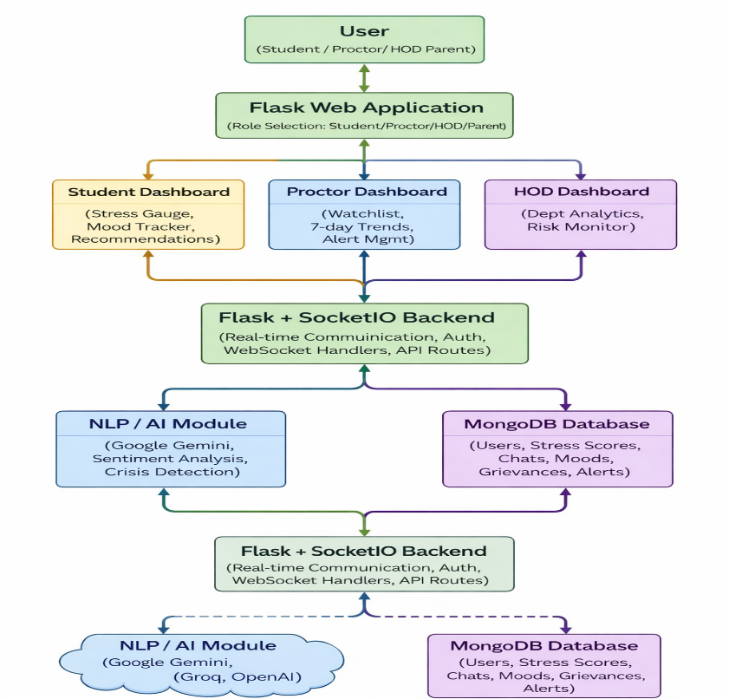
4.1 System Architecture

Figure 1: Aura System Architecture
AURA's system architecture comprises multiple autonomous layers: Role-Based Authentication, NLP-Based Emotional Processing, Student Dashboard Management, Risk Analysis Engine, and Institutional Monitoring. The system is accessed through a web-based Flask application where users select between Student, Proctor, HOD, or Parent roles with secure session-based authentication and credentials registered in MongoDB.
Student interactions with the AI chatbot and mood selections are processed by the NLP sentiment analysis module, which extracts emotional indicators, stress patterns, and behavioral telemetry, storing this structured data as longitudinal wellness records. The risk analysis engine performs dynamic risk calculations using multilingual crisis pattern detection and personalized baseline anomaly analysis based on 21-day historical stress data, generating real-time alerts and intervention recommendations.
The Flask backend manages role-based dashboards with real-time bidirectional WebSocket communication via SocketIO, enabling instant alert delivery and live metric updates across all client interfaces. Proctors monitor assigned students through interactive watchlists displaying 7-day stress trend sparklines and critical risk alerts. HODs access department-wide wellness analytics, longitudinal trend analysis, and high-risk student aggregates. Students view personalized real-time stress gauges, mood history, wellness recommendations, and dynamically adapted emotion-aware interface themes. The Google Gemini AI engine with fallback providers (Groq, OpenAI) powers conversational intelligence and sentiment extraction. The system ensures structured mental health monitoring through continuous behavioral telemetry, automated risk detection, real-time analytics, and coordinated institutional interventions throughout the complete student support lifecycle.

4.2 Role Selection and Authentication Module
This module serves as the primary entry point into AURA where students, proctors, HODs, and parents select their respective roles and securely authenticate into the system. The module collects user credentials (email and password) and validates them against registered user records in the MongoDB database.
Authentication of credential information is performed securely using bcrypt password hashing, with credentials validated against stored hashes in the MongoDB users collection. Upon successful authentication, the system establishes a server-side session and assigns role-specific dashboards and role-specific permissions based on the authenticated user's assigned role (student, proctor, HOD, or parent). The authentication module enforces rate limiting on login attempts using Flask-Limiter with Redis backend in production environments, preventing brute-force attacks. Session cookies are configured with HTTPONLY and SAMESITE attributes to prevent XSS attacks, and are marked as SECURE in production deployments with HTTPS. The system implements CSRF token validation on all state-modifying operations and enforces a configurable session lifetime (default 1 hour) after which users must re-authenticate. Role-based access controls are applied at the route level using authentication decorators, ensuring users can only access endpoints and dashboards appropriate to their role. This comprehensive authentication architecture ensures secure credential validation, granular permission enforcement, and protected session management throughout the application lifecycle.
4.3 NLP-Based Placement Message Processing Module
To eliminate the ambiguity present in unstructured student communication, all student interactions with the AI chatbot are processed through an NLP-based sentiment analysis module, which automatically extracts structured emotional and stress indicators.

Each processed interaction provides:
➤ Sentiment classification (positive/negative/neutral)
➤ Stress score indicators and emotional baseline
➤ Mood category (happy, calm, anxious, stressed, sad, angry)
➤ Crisis keyword detection and risk flags
➤ Behavioral engagement metrics and activity levels

Extracted emotional indicators are cross-referenced with student behavioral profiles so that appropriate wellness recommendations and institutional alerts can be automatically generated. Personalized support resources are matched to detected emotional states and stress severity levels using rule-based filtering. This communication efficiency is increased through structured emotional data collection, organized risk classification, and optimized intervention delivery. The module maintains multilingual crisis pattern detection including English, Hindi/Hinglish, and Spanish keywords to ensure comprehensive coverage across diverse student populations. Extracted data is indexed by timestamp and user email for rapid longitudinal analysis, enabling proctors and HODs to track stress trends, identify at-risk students, and implement timely interventions. The structured output ensures consistent emotional assessment across all student interactions, eliminating subjective interpretation and enabling data-driven institutional decision-making.
4.4 Student Dashboard and Wellness Tracking Module
This module provides the student-facing interface for accessing personalized mental wellness information and support resources. Students can monitor their stress levels, mood history, and emotional patterns with real-time updates.

The system performs:
➤ Real-time stress score calculation and display
➤ Mood history tracking and trend visualization
➤ Personalized wellness recommendations
➤ Emotion-aware interface theme adaptation
➤ Notification delivery for high-stress alerts and support resources

The dashboard guarantees students a clear and organized view of their mental wellness trajectory throughout their academic tenure, enabling self-awareness and proactive engagement with support services.

4.5 Risk Analysis and Proctor/HOD Monitoring Module
The risk analysis engine considers student behavioral history, stress patterns, and engagement frequency to compute dynamic risk classifications. The module provides:
Each processed interaction provides:
➤ Student risk categorization into CRITICAL_RISK, HIGH_RISK, MODERATE_RISK, and LOW_RISK levels
➤ Identification of students exhibiting sustained stress elevations or crisis indicators
➤ Institution-level wellness analytics and departmental trend analysis
➤ Institutional alert management and intervention tracking
4.6 Proctor and HOD Management Module
The system includes specialized management interfaces for institutional stakeholders to oversee student mental wellness activities and coordinate interventions.

The proctor dashboard includes:
➤ Assigned student watchlist with 7-day stress trend sparklines
➤ Real-time risk alerts and critical indicator notifications
➤ Intervention documentation and student follow-up tracking
➤ Direct messaging interface for counseling and support

The HOD dashboard includes:
➤ Department-wide stress analytics and 30-day trend visualization
➤ High-risk student aggregates and risk distribution patterns
➤ Proctor performance metrics and intervention outcomes
➤ Institutional wellness policy enforcement tracking
Timely updates ensure that proctors and HODs maintain comprehensive and organized visibility of student mental health status and institutional intervention effectiveness.

4.7 Algorithm Procedure
- User selects role and logs in with credentials (email/password).
- System authenticates user and initializes role-based dashboard.
- Student selects mood or initiates chatbot interaction.
- NLP module processes interaction and extracts emotional indicators.
- Stress score is computed using mood (0.4) + sentiment (0.3) + activity (0.3).
- Computed stress data is stored in MongoDB with timestamp.
- Risk engine analyzes stress score against historical baseline using z-score anomaly detection.
  - If crisis keywords detected: Risk = CRITICAL_RISK, trigger immediate proctor alert.
  - If stress > 80 OR baseline anomaly detected: Risk = HIGH_RISK, notify proctor dashboard.
  - Otherwise: Risk = MODERATE_RISK or LOW_RISK based on thresholds.
- Real-time notifications broadcast to assigned proctors via WebSocket.
- Proctor reviews student watchlist, initiates intervention if needed.
- HOD accesses department analytics to identify systemic wellness trends.
- System generates longitudinal trend reports for institutional decision-making.

V. Experiments & Results:
A. Evaluation of the System Workflow
The proposed AURA system prototype was experimentally validated based on simulation of realistic campus mental wellness monitoring processes. These procedures consisted of registering students, proctors, HODs, and parents; authenticating users; initiating student interactions with the AI chatbot; processing emotional data through the NLP module; tracking stress metrics and behavioral patterns; and monitoring risk levels. All user roles (student, proctor, HOD, parent) were authenticated and role-based access controls were enforced through backend validation. The system successfully tracked the complete lifecycle of student mental wellness activities including mood selections, chatbot interactions, stress score computations, and risk classifications, with all data properly synchronized to the MongoDB database.
B. Role-Based Dashboard Validation
Role-specific dashboard tests were conducted to ensure operational permissions and content visibility were correctly enforced. Students accessed real-time stress gauges, mood history, personalized recommendations, and emotion-aware interface themes. Proctors viewed assigned student watchlists with 7-day stress trend sparklines, high-risk alerts, and intervention tracking capabilities. HODs accessed institution-wide wellness analytics, departmental trend analysis, and high-risk student aggregates. Authorization validation confirmed that unauthorized access attempts were blocked: backend route decorators and role-checking middleware ensured secure access control and data isolation between user roles.
C. NLP-Based Emotional Processing Testing
The NLP sentiment analysis module was tested on diverse student interactions captured through chatbot conversations and mood selections. Raw conversational inputs were processed by the system to automatically extract structured emotional indicators including sentiment classification, stress indicators, mood categories, and crisis keyword detection. Repeated interaction patterns, varied input structures, and extraction of key emotional attributes were validated for accuracy. The system demonstrated correct extraction and persistent storage of emotional telemetry. Manual spot-checking of extracted sentiment labels against human-annotated test data confirmed the reliability of automated sentiment classification, demonstrating the efficiency of NLP in structured mental health data management.
D. Risk Analysis and Monitoring Validation
The risk analysis module correctly classified students according to their behavioral and stress history. Risk scores were dynamically recalculated based on stress trends, baseline anomaly detection using personalized z-score analysis, and crisis keyword presence in student communications. Students exhibiting stress scores above institutional thresholds or sustained baseline anomalies were automatically categorized as HIGH_RISK or CRITICAL_RISK on proctor dashboards. The system maintained accurate participation and stress records with real-time updates. Proctors and HODs could monitor student risk status in real-time through their respective dashboards. This validated the effectiveness of the risk analysis engine in detecting at-risk students and enabling timely institutional mental health interventions throughout the student lifecycle.
E. User Interaction and Usability Testing
The student interface and usability were tested with undergraduate students, proctors, and HODs. Participants reported that:
➤ The NLP sentiment analysis was automated and minimized confusion arising from diverse and unstructured student communications.
➤ Role-based dashboards enhanced understanding of student mental health status and tracked wellness engagement patterns.
➤ Real-time risk monitoring alerts provided proctors and HODs with quantifiable information about student stress levels and intervention needs.
➤ Students were able to monitor their mental wellness progress and access support resources without requiring technical expertise of backend systems.
➤ Emotion-aware interface adaptation improved user engagement and made the platform accessible to students in various emotional states.
➤ Real-time WebSocket notifications ensured that critical alerts reached institutional stakeholders immediately without manual polling.
F. Comparison to Traditional Mental Wellness Management Systems
The proposed AURA system demonstrates the following advantages compared to traditional manual mental wellness monitoring:

➤ Automated extraction of emotional indicators from unstructured student communications.
➤ Centralized role-based dashboards for all institutional stakeholders (students, proctors, HODs, parents).
➤ Real-time behavioral monitoring and stress tracking without manual documentation.
➤ Automated risk analysis and flagging of at-risk students requiring intervention.
➤ Longitudinal trend analysis enabling data-driven institutional wellness policies.
➤ Reduced administrative burden on proctors and coordinators through automation and intelligent prioritization.

The proposed platform provides mental health assessment at a more trustworthy and objective level through analytics-driven insights, as opposed to manual tracking systems based on spreadsheets or informal observations, which require substantial dependence on human interpretation and introduce subjective bias in student wellness assessment and institutional response.

VI. Tables and Figures:
Test Case ID | Test Scenario Description | Expected Result
TC-01 | Student registration with valid details | Student should successfully register credentials in MongoDB
TC-02 | Student login with valid credentials | System should authenticate credentials with bcrypt and redirect to Student dashboard
TC-03 | Student login with invalid credentials | System should reject login and display error message
TC-04 | Student selects mood on dashboard | Mood should be recorded and stress score should be calculated
TC-05 | Student initiates chatbot conversation | AI chatbot should respond with empathetic message
TC-06 | NLP processes student chat for sentiment | Chat sentiment should be extracted and stored in database
TC-07 | Risk engine detects high stress (>80) | System should flag as HIGH_RISK and alert proctor via WebSocket
TC-08 | Crisis keywords detected in chat | System should immediately flag as CRITICAL_RISK and trigger emergency alert
TC-09 | Proctor login with valid credentials | System should redirect to Proctor dashboard after authentication
TC-10 | Proctor views assigned student watchlist | Student list with 7-day stress trends should display accurately
TC-11 | Proctor receives real-time alert | High-risk student alert should appear in real-time via WebSocket
TC-12 | HOD login with valid credentials | System should redirect to HOD dashboard after authentication
TC-13 | HOD views department wellness analytics | 30-day trend analysis and high-risk student count should display
TC-14 | Parent login with valid credentials | Parent should view assigned child's wellness summary
TC-15 | Unauthorized access to proctor dashboard | Unauthorized users should be restricted with 403 error
TC-16 | Session timeout after inactivity | Session should expire after configured lifetime and require re-login
TC-17 | Stress score recalculation | Risk scores should update dynamically based on new interactions
TC-18 | Emotion-aware theme adaptation | UI theme should change based on detected mood state
TC-19 | Study bot accepts PDF upload | System should process PDF using Gemini API and provide analysis
TC-20 | Grievance submission by student | Student should submit grievance and proctor should receive notification
TC-21 | SMS alert to parent (if enabled) | Parent should receive SMS via Fast2SMS for critical alerts
TC-22 | CSRF token validation | State-modifying requests without valid CSRF token should be rejected
TC-23 | Rate limiting on login attempts | After 5 failed attempts, IP should be rate-limited temporarily

Table1: Functional Validation of Aura Workflow

‘
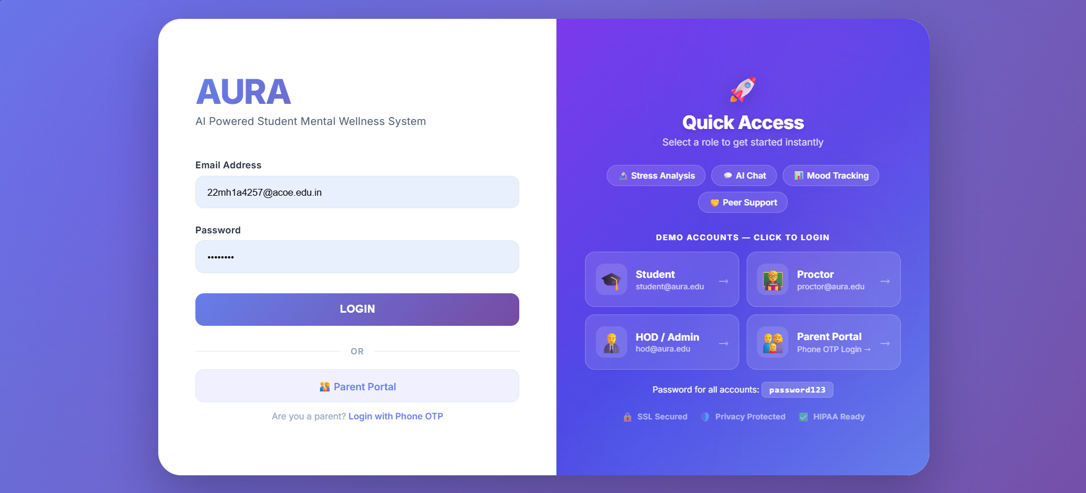

Figure 2: Login and Role Selection Interface

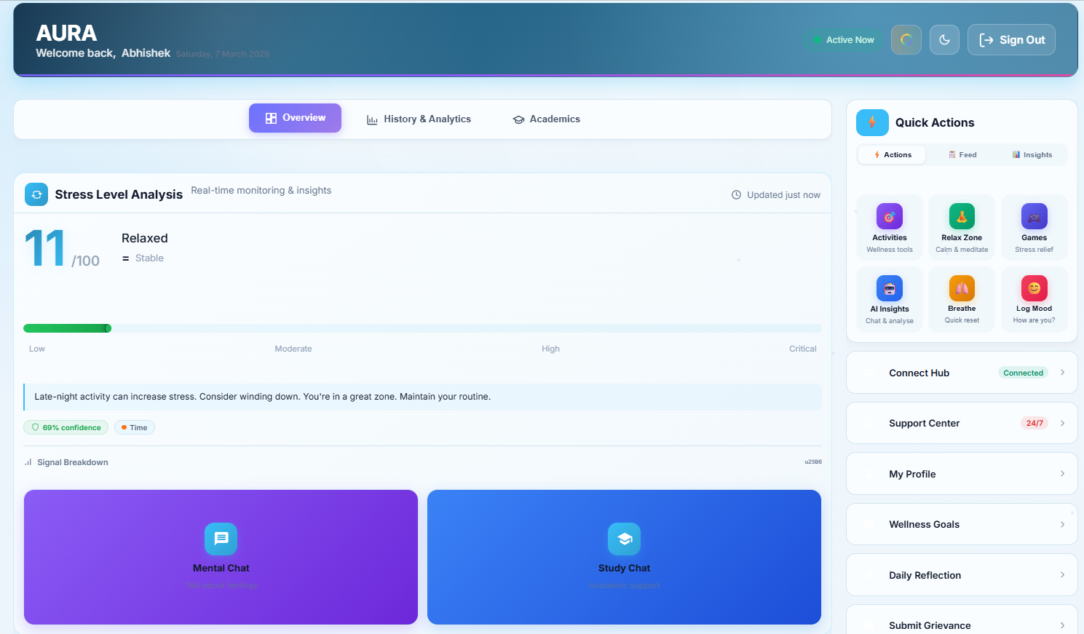

Figure 3: Student Dashboard with Stress Overview

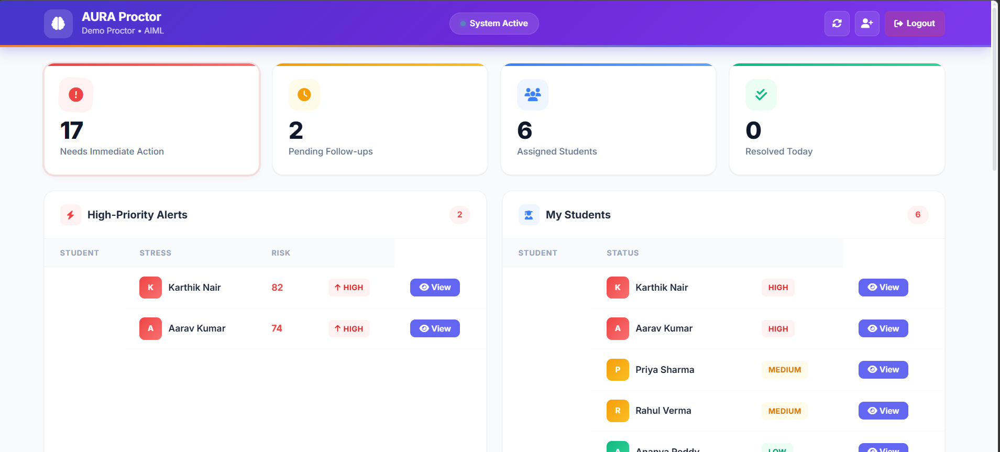

Figure 4: Proctor Dashboard with Risk Overview
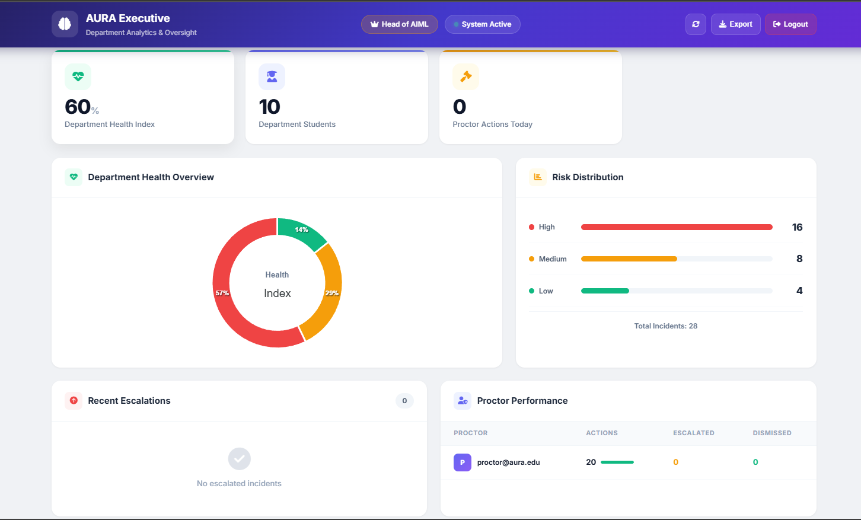
Figure 5: HOD Dashboard with Department Analytics
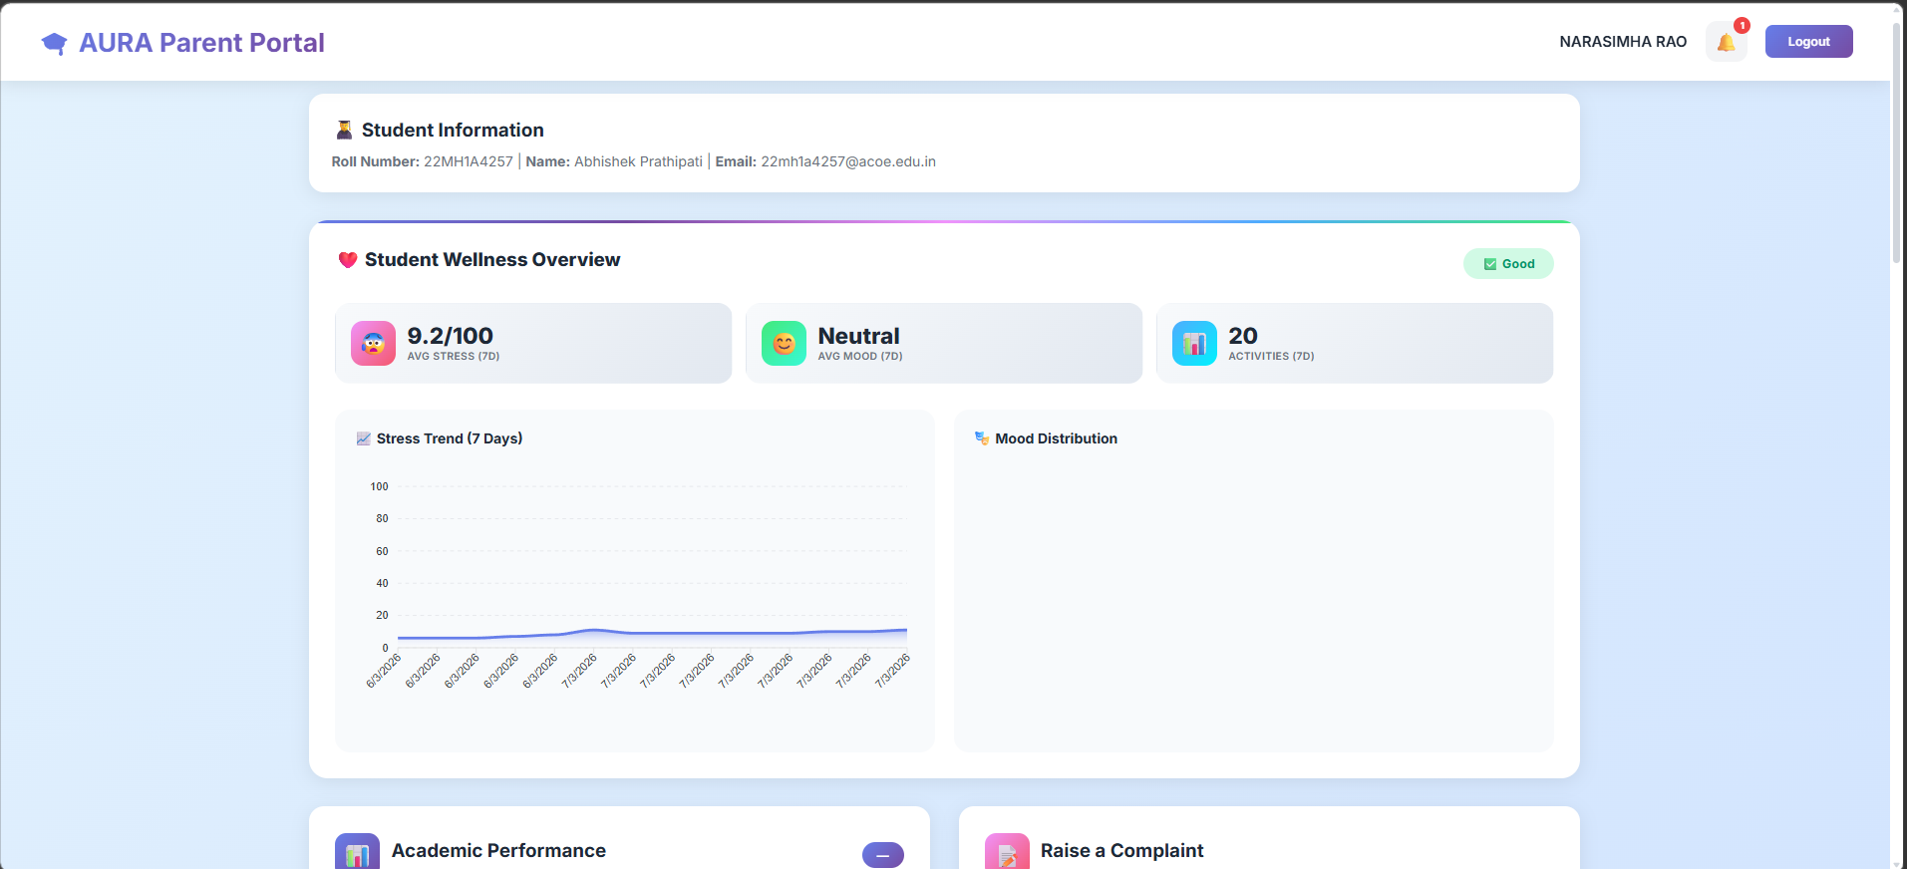
Fig 6: Parent Dashboard with Student Wellness Summary

VII. FUTURE SCOPE
The proposed AURA platform establishes a formalized and analytics-driven approach to campus mental wellness management; however, several areas present opportunities for enhanced scalability, functionality, and intelligence. Advanced AI models with improved emotional understanding and contextual awareness will be prioritized to enhance sentiment analysis accuracy and crisis detection precision across diverse communication patterns and cultural contexts. Machine learning-based predictive analytics for early intervention will enable the system to forecast mental health deterioration before students reach critical stress states, allowing proactive counseling referrals and preventive support allocation.
Microservices-based cloud architecture deployment can significantly improve scalability to support thousands of concurrent students and institutional stakeholders across multiple campuses without performance degradation. Real-time scheduling integration with campus counseling services and automated appointment reminders will streamline access to professional mental health support and improve counselor utilization rates. Integration with institutional health center systems, academic advising platforms, and curriculum data will enable holistic risk assessment combining mental wellness metrics with academic performance and course load indicators.
Peer support group formation through machine learning clustering of students with similar stress patterns and challenges will enable scalable community-based interventions. Gamification features including wellness streaks, achievement badges, and peer challenges will increase student engagement with the platform and improve adoption rates. Advanced authentication mechanisms including OAuth 2.0 integration with institutional identity systems and optional biometric authentication will enhance security while reducing login friction.
Mobile application development for iOS and Android platforms will extend accessibility beyond web browsers, enabling on-the-go mood tracking and instant chatbot access. Integration with wearable health devices (smartwatches, fitness trackers) to capture physiological stress indicators (heart rate variability, sleep patterns) will provide multi-modal stress assessment beyond behavioral telemetry. Implementation of blockchain-based audit trails for sensitive mental health records will enhance privacy compliance and regulatory adherence. These enhancements will transform AURA into a comprehensive, institution-wide mental wellness ecosystem that seamlessly integrates technology, human support, and evidence-based interventions to effectively serve modern educational institutions.
VIII. Conclusion
In addressing the weakness of unstructured and decentralized mental health communication within academic institutions, a centralized and intelligent mental wellness management system named AURA has been proposed in this paper. The system integrates automated emotional assessment through NLP-based sentiment analysis, role-based analytics dashboards, and real-time risk monitoring at the institutional level into a single unified web platform. The architecture comprises a Flask-based backend, responsive HTML/CSS/JavaScript frontend, MongoDB database infrastructure, and real-time bidirectional WebSocket communication via SocketIO, enabling it to scale across institutional deployments while providing all stakeholders—students, proctors, HODs, and parents—with intuitive and accessible interfaces for mental wellness engagement and intervention coordination.
AURA successfully addresses critical gaps in traditional manual wellness tracking by automating emotional assessment, enabling data-driven institutional responses, and establishing continuous monitoring of student behavioral patterns. The system's modular design, multi-provider AI integration with fallback mechanisms, and comprehensive role-based access controls ensure both security and scalability. Through real-time dashboards, personalized stress tracking, and coordinated institutional alerts, AURA bridges the communication gap between fragmented student-support channels and organized data-driven mental health management, creating a platform capable of identifying at-risk students before crises occur and enabling timely, evidence-based interventions. This solution demonstrates the feasibility of deploying institution-wide AI-assisted mental wellness platforms that maintain student privacy while enhancing institutional oversight and care delivery.
IX. References
[1] J. Devlin, M. Chang, K. Lee, and K. Toutanova, "BERT: Pre-training of deep bidirectional transformers for language understanding," Proceedings of NAACL-HLT, Minneapolis, USA, pp. 4171–4186, 2019.
[2] T. Mikolov, I. Sutskever, K. Chen, G. Corrado, and J. Dean, "Distributed representations of words and phrases and their compositionality," Advances in Neural Information Processing Systems (NIPS), vol. 26, pp. 3111–3119, 2013.
[3] A. Vaswani et al., "Attention is all you need," Advances in Neural Information Processing Systems (NIPS), vol. 30, pp. 5998–6008, 2017.
[4] M. H. A. Wahab, M. A. Rahman, and A. R. M. Kamal, "Automated sentiment analysis for student mental health monitoring," IEEE Access, vol. 9, pp. 102620–102630, 2021.
[5] N. D. Gist, P. J. Dennie, and S. Graham, "Stress and coping among engineering students: A longitudinal study," Journal of Educational Psychology, vol. 112, no. 4, pp. 892–908, 2020.
[6] A. Gupta, N. Kumar, and R. Kaur, "Role-based access control and real-time dashboard analytics for institutional management systems," IEEE Transactions on Learning Technologies, vol. 14, no. 5, pp. 601–612, Oct. 2021.
[7] C. Romero and S. Ventura, "Educational data mining: A review of the state of the art," IEEE Transactions on Systems, Man, and Cybernetics, vol. 40, no. 6, pp. 601–618, Nov. 2010.
[8] R. W. Picard, "Affective computing," MIT Press, 1997.
[9] M. Calvo and S. D'Mello, "Affect detection: An interdisciplinary review of models, methods, and their applications," IEEE Transactions on Affective Computing, vol. 1, no. 1, pp. 18–37, 2010.
[10] A. P. Sanford, D. C. Hunter, and J. P. Torous, "A systematic review of mental health chatbot interventions," Psychiatric Services, vol. 72, no. 8, pp. 829–836, 2021.
[11] S. Abd-Alrazaq et al., "An overview of the features of chatbots in mental health: A scoping review," International Journal of Medical Informatics, vol. 132, pp. 104–118, 2019.
[12] N. Sharma, A. Patel, and R. Desai, "Crisis detection and intervention systems for mental health in academic settings," IEEE Transactions on Biomedical Engineering, vol. 68, no. 5, pp. 1456–1468, 2021.
[13] M. P. Gomes, C. da Silva, and R. A. Oliveira, "WebSocket-based real-time communication for educational dashboards," Journal of Educational Technology & Society, vol. 24, no. 2, pp. 215–228, 2021.
[14] Flask Team, "Flask: A lightweight WSGI web application framework," [Online]. Available: https://flask.palletsprojects.com/
[15] MongoDB Inc., "MongoDB: A NoSQL document database," [Online]. Available: https://www.mongodb.com/docs/
[16] Google Developers, "Gemini API: Multi-modal AI for developers," [Online]. Available: https://ai.google.dev/docs/
[17] Miguel Grinberg, "Flask-SocketIO: WebSocket support for Flask applications," [Online]. Available: https://flask-socketio.readthedocs.io/
[18] OWASP, "Top 10 Web Application Security Risks," [Online]. Available: https://owasp.org/www-project-top-ten/
[19] Python Security, "Bcrypt: Secure password hashing for Python," [Online]. Available: https://pypi.org/project/bcrypt/
[20] Z. Zubair, R. Malik, and A. Khan, "Real-time monitoring and risk assessment using machine learning algorithms," IEEE Sensors Journal, vol. 21, no. 6, pp. 7734–7745, 2021.
[21] L. Breiman, "Random forests," Machine Learning, vol. 45, no. 1, pp. 5–32, 2001.
[22] G. Siemens and R. S. J. d. Baker, "Learning analytics and educational data mining: Towards comprehensive understanding of learning," Proceedings of the 2nd International Conference on Learning Analytics and Knowledge, pp. 252–254, 2012.
[23] P. Brusilovsky and E. Millan, "User models for adaptive hypermedia and adaptive educational systems," in The Adaptive Web, Springer, 2007, pp. 3–53.

